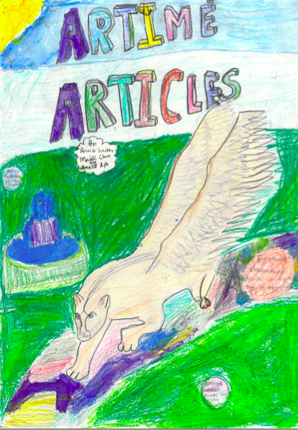
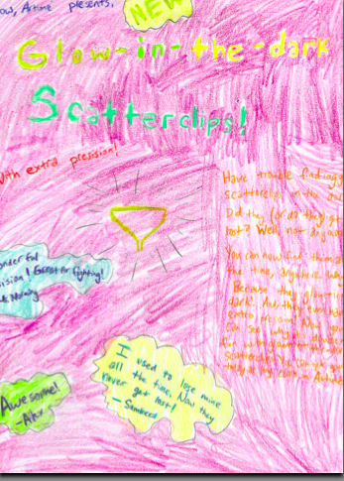

The Journey By: Maddi Chu

Mr. Today sat down. He had a tiny smile. “Tell us a story!”, the new set of Unwanteds pleaded.
Okay, agreed Mr. Today.
“Of your childhood” added Alex.
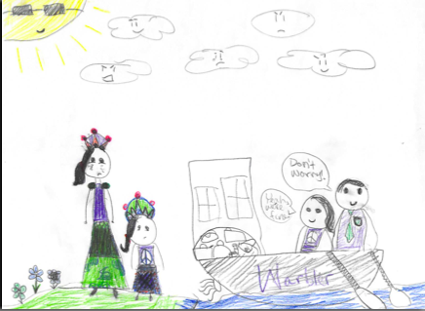
A long time ago on a small Island named Warbler, Justine and I lived there. My mom and dad ruled the island. I had a happy life. We had a sister named Eagala and we lived in awesome mansion type place. I had magic too! Justine and I longed to go to the other islands. We pleaded our parents. “NO” they always said. Why not I once? Asked them. You won’t be safe! You can come! You know magic! Like always it was NO!
We soon learned magic. My mom and dad were the best at it. I think I got there genes. So soon I got really good at it. Not so Justine. “Can we please go to the other islands?” Justine and I asked, on the day I learned the hardest spell. NO they said like always. I still longed to go to the other islands. It was my dream! Day after day I studied hard. It was not much fun. My parents saw that and they sent for an arena to be made. Justine and I were excited. But I still longed to go to the other islands. We got to battle each other with new magic skills. It was fun but most likely not as fun as going to the other islands.
The day I turned 16 at my birthday dinner only mom, dad, Justine and my younger sister were there. Dad had a sad face on. Mom looked worried. It was dead silent. So what’s wrong? I asked. Breaking the silence.
“We have decided you can go!”
“We can?”
“Yes”, dad said.
“THANK YOU!! ” I was never happier in my life. We cut the cake and ate. Wow I can’t believe were going! I said to Justine. “Yep!” she said. That night, instead of schoolwork we built a big boat. Weeks passed, and soon the right day came. It was sunny outside and not many clouds were in the sky. We soon set off. Our family was crying, especially my mom. “ “Don’t go” my sister cried. My mother threw a little stone kitten in to my hands. “Bye” she said. A kitten! Justine cried cute! We started to row. They grew smaller and smaller.

“Our journey begins”! I said
“Yeah it’s kind of sad, said Justine.
“We did live there our whole life”!! I told her.

Harder Marcus urged Justine. “I am”! “Geez”! We paddled and paddled all day long. At night we stopped. “WOW it’s amazing”! We breathed“ Way better then the bedroom window”! Justine said. “You bet”! I murmered.
When we woke up the next morning it was sunny and bright.
“Oh, I remember it”! “The first day!
“ Mr. Today”! The Unwanteds cried.
“Ah yes, sorry”! “Where were we again? Brain fogs getting to me.
Well we ate a yummy breakfast of pastries and started rowing again! Days passed but we still paddled. One day there was a big storm. First only tiny drops but it got BIGGER and BADDER! Lightning and thunder howled! “Marcus”? Justine yelled but I barley heard her.
“’Right here”! I hollered. From the little cabin we had. With the tiny magic we had I held up the boat. (Justine didn’t know how to)
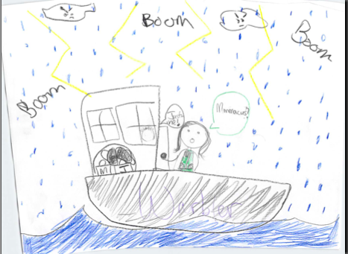
The storm soon passed and we paddled some more. “It has been a 2 months since we were home”! Complained Justine.
“I see LAND”! I screamed.
“You do?” Justine asked.
“Yeah, little bits of land”!
So we paddled faster and harder. In about 30 minutes we got there. When we reached the land. Not a single person was there!
The Purge by Annie Smith
I sat there scared,
Even though I was not supposed to be.
I sat there nervous,
Even though I was not supposed to be.
My brother
Was wanted; I was not
Because, I was,
Unwanted.
Bright Lights
Staring
My eyes were wide
So new
so different
it was amazing
the new place
with bright lights.
“We shall take over”! Justine cried.
Uh huh. I murmured. “Wait what”! “What did you say”?
“Take over” she repeated.
“Not in a million years”!
“Why not”? Justine asked.
Um. I don’t know.
Right we should take over.
“NO”! I cried.
“YES”!
“NO”!
She got ready to punch.
I got ready to do a spell.
“Oh fine”. I sighed.
“YES”! She yelled.
“But if she kills” I protect. I muttered.

So the next day we built all of Quill! It was sort of fun!

The Creation Of Artimé By: Amelia Ash
It all started at a meeting. “Well, let’s get to the point of the meeting,” I said, anxious to see what Justine was going to next to the Quillens. 7”Listen, Marcus. I want to stop freezing the Unwanteds–“ “Great!” I interrupted. “I knew you would find out that the Unwanteds should be treated equally!” “No, Marcus! Don’t you get the point!? I only want to stop freezing the Unwanteds because, in return, I will kill them instead!” Justine shouted. My smile immediately faded. I felt a lump form in my throat.
“Well, what do you think, Marcus?” Justine asked when we had had 5 minutes of silence. “No,” I said, as plainly as that. “No?No!” Justine exclaimed, very angry. “You dare challenge the High Priest Justine of Quill?!” “Yes,” I said, quietly. ”I do.” “Then why?” Justine boomed. “Well, it–it isn’t right. We can’t kill people for being what they are,” I said, getting angrier at the minute. “It just isn’t right.” “I do not except your challenge!” shouted Justine. “My final decision is the Unwanteds will be killed, and thrown into the Great Lake Of Boiling Oil!” “All right,” I murmured, but inside, I knew that, somehow, I had to save the Unwanteds. “Good night,” said Justine, walking into her palace. I walked home, thinking “How could Justine think we should kill the Unwanteds?” I needed to save the Unwanteds. But even through the whole walk out of Quill, I was still without ideas. I sat on my chair in the shed, and decided I needed a whole world for Unwanteds. But before any other ideas popped up, I fell asleep.
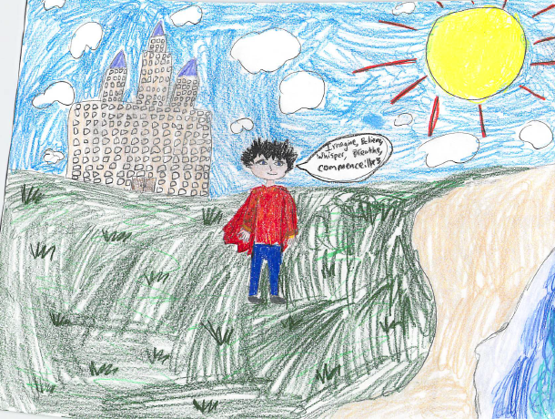
A week later, I had an illustration of my new Unwanteds world (I decided to call it Artimé), but I was still figuring out how to make the spell for it. “Believe, Breathe, Whisper, Imagine, Commence?” I tried. “No, that wouldn’t work. How will I make it secret? Oh, that’s for another day.” I said to myself. “Today I just have to find the spell. Wait, is this it? Imagine, Believe, Whisper, Commence, Breathe? No. What could it be?” But then one day later, it struck me.
“Imagine, Believe, Whisper, Breathe, Commence. Yes, that’s it! Imagine, Believe, Whisper, Breathe, Commence! But now what? I don’t think just the spell will work,” I said. Then my eyes caught on to my pile of colorful robes.
“Aha!” I said. “I’ll use these, too! But how?” I thought. “Oh, of course! I’ll wear them while I say the spell. But unfortunately, it was night when I discovered that, so I had to wait for morning. I was so anxious, the minutes felt like hours, and the hours passed like days, but finally, finally it was tomorrow.
At the break of dawn, I jumped out of bed, put on a robe, and stepped outside. “Where should I go?” I asked myself, but in the end I decided to go to the part of the place where the sea was close by, and weeds were everywhere.
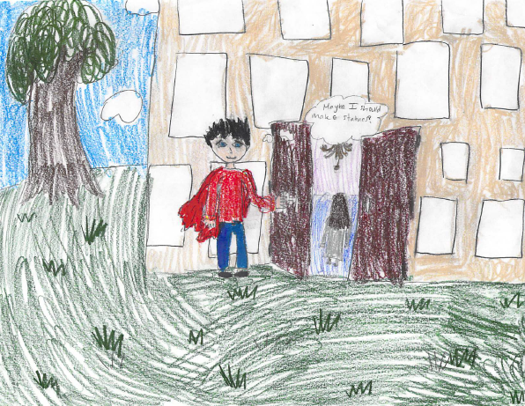
I was so scared, but made myself start. I thought hard about what I would like Artimé to look like. “Imagine,” I said. I thought some more. “Believe.” I thought even more. “Whisper,” I said. I kept concentrating. “Breathe,” I said. More thinking. “Commence,” I finally said. But nothing happened. I repeated it. Nothing happened that time, but on my third time, I saw the little bit of Quill transition into a beautiful, colorful world. Artimé. Just how I had imagined it.
“Wow,” I said, amazed. It was beautiful. Animals were moving around. But there was no one else to share it with. I better start unfreezing the Unwanteds,” I thought.
So, right after I had done the spell, the world was alive with many people. “Wow” and “cool” were some of the comments the children made.
“Playprot!” said an animal. I decided to name that species “platyprots” because of it.
But then, I had an idea, as I was leading the Unwanteds to the amnion, and through the girl-and-boy hallways. “Maybe I should make a statue to stand by the front of the mansion,” I thought. “Anyway, compared to making Artimé, making statues will be as easy as stealing candy from a baby!
7 Before Quill started “killing” Unwanteds, High Priest Justine, the ruler of Quill, had Mr. Today freeze the to punish them.

Mr. Today and the making of Simber Part 3 by Annie Smith
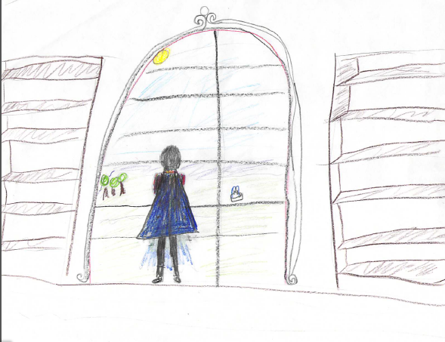
Artimé was just finished when Mr. Today thought “when the Unwanteds get hear it will only be me and them, there are some animals living in the jungle but they need a animal that will live around them.” he walked around the lawn and outskirts of the jungle and thought “it does feel empty without any animals oh well I will think about it tomorrow.” He walked back inside the mansion and went to his chambers to go to sleep.
That night he dreamed of himself making an amazing statue ... it had a long thick tail, kind eyes, strong wings and broad shoulders. It was amazing it had everything he wanted a magical creature to have he was just about to breath life into it when he woke.
That morning all he could think about was the animal from his dream. It made him wonder if he could make something so amazing. He spent the rest of the day adding last touches to airtime but that was at the back of his mind , he was thinking more about the amazing animal in his dream.
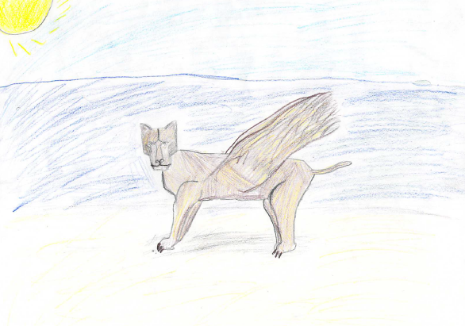
When he walked back inside the mansion he looked at the big double doors “ I should put something to the side of the doors…” but he could not think of what to put there. “oh well” he said walking away “ that will just have to wait.

When Mr. Today went to sleep that night he had the same dream about the amazing creature but it was even more vivid this time he could see that the creature was standing on a beach. He could see every tiny grain of … wait what!? The creature was made out of sand. How could something so delicate look so powerful? This animal was starting to truly amaze him.
The next morning Mr. Today woke up at 7 am. After getting himself ready for the day he went down to his kitchenette and had a small breakfast of a muffin and a glass of orange juice.
He walked around the property lost in thought. He was trying to think about making this place better for the Unwanteds but his mind kept going back to the animal in his dream…” the animal was truly spectacular with the animals majestic wings, amazing detail, and of course his beautiful eyes, oh his eyes they where amazing with all the detail and depth they where so life like.
Mr. Today went back to his private quarters and into the museum of large and got his journal out and started writing. “Artimé is almost done but I might put something next to the door maybe a statue. Anyway I have been having a reoccurring dream about a winged cheetah made of sand. I have an idea about making a living statue to live in airtime maybe even a living creature that is not a statue.” Mr. Today closed his journal and looked around the room it looked empty. Endless rows of shelves only halfway filled “someday” he said to himself “someday.”
Mr. Today was looking out the window over Artimé when his eyes landed on the beach. The sand sparkled like diamonds “wait” he said to himself “the winged cheetah was made out of sand! I know what the dream meant!!! He ran to the beach as fast as he could.
When he got to the beach he walked over to the wet sand grabbed a big chunk and put it on the dry sand. He kept doing this until he had a pile bigger than him. Once he had that he started sculpting. He made large paws, muscular legs, elegant wings, and sharp fetchers. More than one time he had to do a part over again but finally he finished six hours later. He stood back to admire his work. He took a small piece of rubber from his robe and threw it at the statue. It covered a small amount of the statue. He kept throwing pieces of rubber until the hole statue was covered. Then he did the live spell. He put his hands on the statues sides and started ”initiate, invigorate, instill, improve, comfort, happiness, peace, success, loyalty, devotion, zeal, intensity, passion.” Then he said the name he had come up with “Simber. “ Simber slowly came to life. He opened his eyes. he moved his paws. He moved his wings. And then he said hello Marcus Today.
Mr. Today jumped for joy when he heard Simber speak “this is amazing” Mr. Today said. Simber smiled proudly “I am hear to help Artimé and to help you.”
“hum” Mr. Today said a week later. “ maybe soon I will make another statute because Simber turned out so good I know I will make an elephant!”

Artime Articles by Amelia Ash
You should read The Unwanteds because the story is structured well, the characters are well-explained, and the story is fun and exciting to read.
One reason that you should read The Unwanteds is that the story is weel-structured. For example, everything makes sense in the story. Also, the story is in order. And, it’s realy cool how the story goes back and forth between Alex and Arron’s point of view. So if they are experiencing the same event, it’s cool to see the different points of view.
My second reason that you should read The Unwantds is that the characters are well explained. For example, Alex is explained that, because he is creative, he is unwanted. And, his brother Aaron is explained that , since he is not creative, he is a Wanted. High Priest Justine is explained that she hates creativity, and Mr. Today is explained that he thinks creativity is a gift, and they should use it.
My last reason that you should read the Unwanteds is that the story is fun and exciting to read. For example, the Unwanteds, instead of being killed, are sent to Artime by Mr. Today. Also, the Unwanteds learn magic in Artime, which makes the story even more interesting.another exxample is in Quill, they might discover Artime even it’s secret! And my last example is Quill and Artime might have a battle!
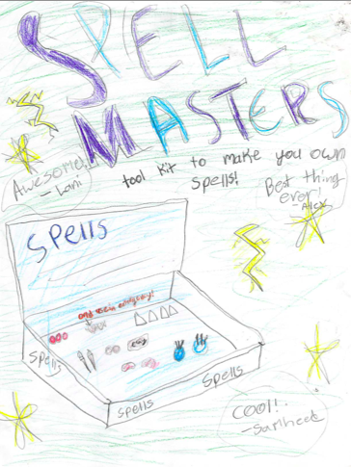
If you like interesting characters and exciting stories, what better series to read than the Unwanteds? The story is well-structured, the characters are well explained, and the story is fun and exciting to read. So, what are you waiting for? Read the Unwantds!

Unwanteds are better than Wanteds By Annie Smith
Unwanteds are better than wanteds because they are creative. Wanteds have NO imagination they always lesion and have no creativity whatsoever. Unwanteds are very creative and have a HUGE imagination. They are much kinder than Wanteds and always are being creative brains. Wanteds are mean and boring creativity is one of the most important things in life. And Unwanteds have lots of creativity and Wanteds have none.
One reason why Unwanteds are better than Wanteds is because Unwanteds are creative. They are the people who make things without creative people nothing new would be made. Every unwanted is creative but only a couple Wanteds even know how to write. In Quill where the Wanteds live creativity is a crime. That’s how you become an unwanted you get caught being creative. In quill they don’t like creativity so much that if you get caught being creative they get sent to there deaths. The Unwanteds are all the people who where supposed to get sent to there deaths but got sent to Artime.
Another reason Unwanteds are better than Wanteds is that Unwanteds know that creativity is not a crime and they will always use creativity when ever they get the chance. Creativity is the one power that the Wanteds do not have. The Wanteds have weapons and machines but they do not have creativity.

CREATIVITY IS NOT A CRIME! By Maddi

What people need to know is that Creativity is not a crime! Creativity is one of the most important things in life! Creativity is what you need in life! Right now I’m being Creative! If I were in Quill I would be sent to the Ancient Sectors! If I were in Artimé I would be complemented!
If Creativity were a crime I would not be telling you this! If Creativity were a crime you would not have any fun! Creativity is almost everything! Creativity is not a crime! Having fun means having a good time! Fun is very important in life! Fun is one of the number 1 thing in life! If you don’t have fun! Your life will be boring!
If being Creative is fun, and you want to be fun then Creativity is not a crime! Everyone wants to have fun! Creativity is like art, writing, acting, music, magic and way more! Watching or doing all those things is Creativity and Fun! In the Unwanteds book, Artimé is where all the Creativity happens! In Quill is where all Creativity is FORBIDEN!! Plus you will die! Which one do you want to be in? Artimé right!
Creativity is almost everything! Creativity is not a crime! Creativity is the most important things in life! You are Creative every day! Try not being Creative for a day you will find it very hard! You will see that you are creative every day!

Sky and the island of Legends by Annie Smith
I sat at the back of the boat looking out to sea. “Why is Alex acting so weird?” I thought to herself. “It does not matter.” she thought “I have to think about saving my mother.” I looked out to sea and could see pirate island pretty clearly now they were getting close. I looked out at it wondering what my mother was doing. Just then Alex ran up from below decks and got everyone’s attention. ”Ok we are almost at pirate island so hears the plan. We’ll wait for Sky and Crow’s mother by the skylight. Her name is copper by the way , which is also the color of her hair, so that will help you identify her.” Alex glanced at me to make sure he had gotten the details correct. I nodded. “Her hair is long and a little bit lighter than mine” I said. and she has golden/ orange eyes and a thorn necklace as well.” “Sounds like she is not hard to miss,” Sean said. “Right, Crow?” He’d taken quite a liking to Warbler boy. Crow nodded. “She is beautiful”, he said. Carina’s hand flitted to her mouth and her eye’s glistened. “It’s settled then,” she said, patting the boy on the knee. “We shall save her.” Carina had a young son of her own and was no doubt thinking of him. She gave my shoulders a squeeze.
“Once we’ve spotted Copper and alerted her to our presence, we will communicate a time for her to sneak out of the fishing hatch and will take her from there. And if she is unable to access the hatch or is too afraid because she can’t swim, we will have her return to the spot by the skylights. Florence can smash in the windows and we will lower a rope and pull her out that way”. Samheed yawned. “Sounds easy, You probably won’t even need us.”
“That’ is where phase 2 comes in.” Carina perked up her ears. “Phase 2 ,I’m listening”.
“You guys remember the animals right? The sea creatures caged underwater on the other side of the reverse aquarium? some people saw them the last time we were there.” Alex said.
Crow, Simber ,Carina, and I nodded. “Are we going to set them free?” Crow asked, excited.
“We’re going to try, they should not be trapped like that.” Alex said. Simber glanced at Ms.Octavia “Can you communicate with water creatures?
“I have never done it before but i can try.”
“ Well its settled then.” Alex said
They were going to save my mother.

SAMHEED by Maddi Chu
General Blair threw his son Will Blair out in the middle of us. Artimé and Quill. We gasped. “NO!” I screamed. You can’t do that! I cried. His father killed him! How could a father do that! I threw my throwing star at him. It hit him square in the neck. “They hit the general” I heard Quillantary soldiers say. They shot their useless BB guns. CREATIVETY IS NOT A CRIME!!!!!!!! I wanted to yell.
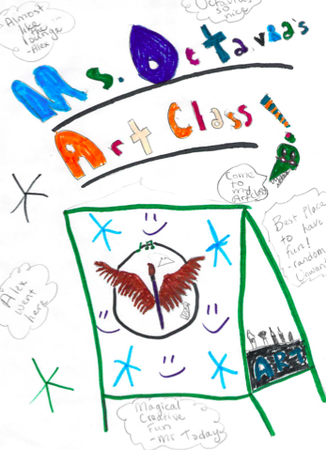
But that would make a big scene so I didn’t. I got back to the battle. Spells were flying everywhere! I heard Florence load voice. She told us “to use permanent spells” so I did. I threw some scaterclips. Then I stopped dead in my tracks. Where was he? I started searching for him. My DAD. I spotted him right there under *Mr Appleblossom’s favorite tree. I waked up to him. “Uh hi dad”. The words sounded different to my mouth. My hands sweating like crazy! “Don’t call me dad” my father spat.
“You got to listen”- I began calmly. He cut me off. Your no son of mine! To you creative useless Unwanted! He took out his gun. The ones all governors use the good ones for emergency. He pointed it at me. “NO dad you don’t understand!” but then a sword hit him. The type I use for prop. MR.A?? Mr. A jumped down from his perch. “NOO Mr. A! Sam”- “I wanted to see if he would do it”! “Sam I understand”. He said repeating himself.
“But it’s for Artimés own safety. “Yeah I guessed that”. “I said looking down at my feet. “Now get yourself to the hospital wing”! He said looking at my arm all cut you could almost see my bone! He walked me back to the mansion. I decided I like Artimé way better then Quill.
(*Mr. A is Samheed’s private drama teacher.)

The Adventure to Warbler By: Amelia Ash
“Samheed! Alex! Meghan!” I exclaimed. “What is it?” asked Samheed. “Do you want to go on a holiday like Mr. Today?” I asked them. “As long as it isn’t to Quill!” said Meghan. “Yeah. If it’s to Quill, I’m out,” said Samheed. “I don’t know how I’d live without using creativity. I mean, yeah, we didn’t in Quill, but, seriously, that was Quill.” But Alex said, “Sorry, guys, I don’t think I can come because I’m so busy with *Mr. Today going on his holiday and all. It took him years and years to learn all this, and he expects me to learn it all in a few weeks!”
“Well, okay,”sighed Meghan. “But you’re going to miss out on a lot!”
Later today, we went outside onto the beach to set off on our trip. “First, we have to find out how to start the boat, then go off on our adventure,”I explained to Samheed and Meghan. “But how will we start the boat?” asked Meghan. “I think it’s magic. Alex once said that once you say the spell, you just point the boat in the direction you want it to go, and it does,” I told them. “But what if Mr. Today and Ms. Morning don’t want us to use the boat?” asked Meghan. “They never said we couldn’t!” said Samheed. “Well, okay,” said Meghan, and we all waded out to the boat, and we started the boat.
A couple of hours later, we took off our shoes and vests, but Samheed hesitated while taking off the component vest.”What should we do with these?” he asked. “I’m not sure, but I know the paper and clay components will be ruined,” I said, hoping Meghan had something to say. Luckily, she did.
“We could just bring the metal and rubber components with us,” she said. “Anyway, it’s not likely we’ll need anything.” “And the vests?” I asked. “Just leave them here, and put some components in your pockets,” said Meghan. “I guess that will work,” said Samheed, nodding. I slipped a few scatterclips and dementia spell components in my pockets, and Meghan and Samheed did the same.I cast an anchor spell (the instructions were by the wheel) and felt a tug on the boat.
Satisfied, I told Meghan,” I wish we had thought to bring a change of clothes.” Meghan shrugged. “We’ll dry,” she said, and jumped int the water. “C’mon, you guys!”
Samheed and I needed no further urging. We jumped into the water, joining Meghan. We swam ahead, and when we could reach the bottom, ran towards the beautiful beach. “Ahh…” sighed Meghan. “This feels so relaxing,” I said. We stayed there for about a minute longer, then made our way up to the beach. I thought it didn’t seem much different from the beach in Artimé, but it seemed somehow special, in a way, thanks to our adventure getting there.
But, suddenly, I sat up. “Something’s weird,” I said, surprising everybody. “What do you think is weird? You can’t possibly be thinking about how this place might be related to AQuill because, well, it doesn’t. It looks so creative here, unlike Quill,” said Meghan, sounding surprised. She obviously didn’t have my suspicion. “I thought so, too. No, it’s not like Quill here,” said Samheed, sitting up. “It’s just too quiet,” I said. “There’s no sound except for our own voices.” “Exactly. I mean, no animals—I understand, but no sound coming from the waves? Something’s going on, and it’s very strange,” said Samheed. “Suddenly, I’m not so sure about this place,” Meghan said, sounding worried. She looked very concerned. “Should we run away?” I thought to myself. But before I could move (or any of the others, as they were thinking the same thing), I felt a sharp, painful poke between my shoulder blades.
With no chance to cry out, we exchanged a look of terror right before our bodies went limp and unconscious, and we dropped back onto the sand.

- Mr. Today had worked for about 50 years straight, so he decided to go on a short vacation so he could rest.

Any creativity is a crime in Quill, unlike Artimé. If you get caught using creativity, you will become an Unwanted, which means you are supposed to be thrown into the Great Lake Of Boiling Oil, but are really sent to Artimé, where creativity is a talent.

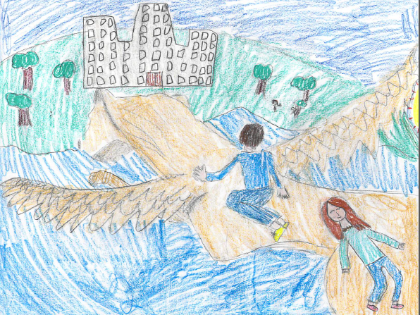
When Simber Sinks By Amelia Ash

Soaring
through the sky,
flying,
until,
All of a sudden,
my wings
are stiff.
I drop down,
and sink
into
the bottom
of the sea.

Poems by Maddi Chu
ARTIMÉ

CREATIVE loads of fun! Everywhere is magical!
ALL AROUND YOU IS COLORFUL.MANY CREATERS. LIKE…

SIMBER
AND
FLORENCE!
ALL OF THEM ALL MAGICAL

AND LIVE IN THE COLORFUL
WONDERFUL
CREATIVE
WORLD OF…

ARTIMÉ
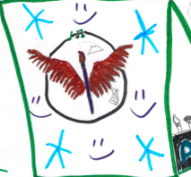

Scaterclips By Maddi Chu
Super
Amazing
Creative
Technology
Exciting
RUN!
Collect it
Love it!
Improved
Popular
Superb

